Install backend dependencies:
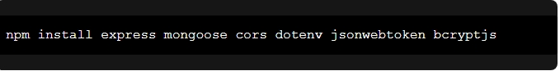
Package Purpose:
express → Backend framework
mongoose → MongoDB connection
cors → Cross-origin requests
dotenv → Environment variables
jsonwebtoken → Authentication
bcryptjs → Password hashing

